Complete the sentences.
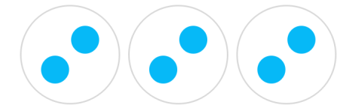
There are ____ equal groups with ____ in each group. How many all together?
2 + 2 + 2 =

There are ____ equal groups with ____ in each group. How many all together?
3 + 3 + 3 + 3 =

There are ____ equal groups with ____ in each group. How many all together?
6 + 6 + 6 =

There are ____ equal groups with ____ in each group. How many all together?
5 + 5 =

There are ____ equal groups with ____ in each group. How many all together?
4 + 4 + 4 =
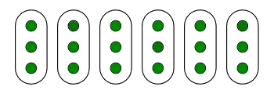
There are ____ equal groups with ____ in each group. How many all together?
3 + 3 + 3 + 3 + 3 + 3 =

Describe the equal groups.

What is the same and what is different in each group?
_________________________________________________________________________________________________________________________________________________________________________________________

