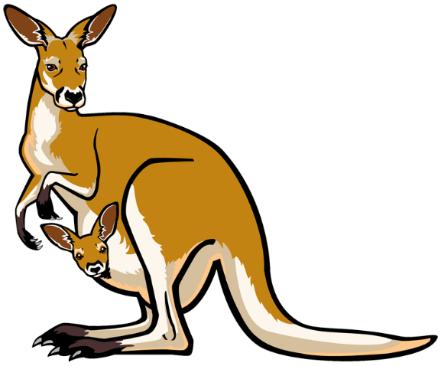**Kangaroos**

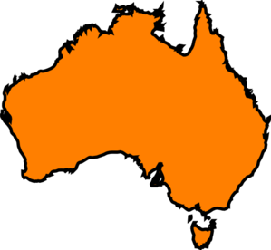

**What does a kangaroo look like?**

**What are baby Kangaroos kept?**

**What fact did you find interesting?**

**How fast can a kangaroo hop?**

**Where do Kangaroos live?**

**What do Kangaroos eat?**