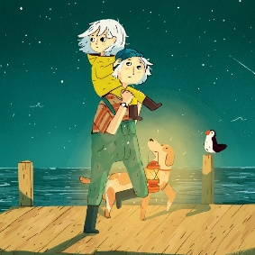

What do you think about Erin’s lack of fear or her behaviour?

___________________________________________________________________________________________________________________________________________________________________________________________________________________________________________________________________________________________________________________________________________________________________________________________________
Do you agree that she should keep trying to hide on her mum’s boat? Why? Why not?

_______________________________________________________________________________________________________________________________________________________________________________________________________________________________________________________________________________________________________________________________________________________________________________________
Why does she wait for her mum every night?

_______________________________________________________________________________________________________________________________________________________________________________________________________________________________________________________________________________________________________________________________________________________________________________________
Why is she so interested by Black Rock?

______________________________________________________________________________________________________________________________________________________

