Maths activities – Thursday 21st January 2021

Now have a think about different ways you could represent tens and ones. Here are some examples:
Lego Skyscrapers and igloos Giraffes and tortoises
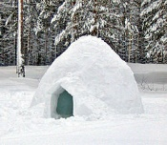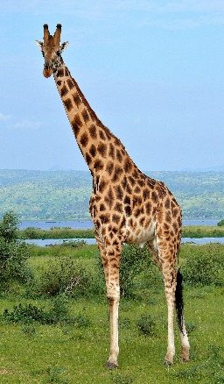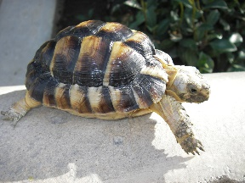

Draw your own representations here:
tens | ones

tens | ones

Then use your chosen pictures to represent these numbers in different ways:
34

28

40

16

