“Where Broccoli Comes From”
By Michael Rosen
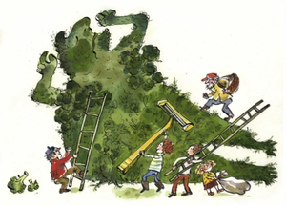
Not many people know
that broccoli grows in the armpits
of very big green men
who live in the forest
and brave broccoli cutters
go deep into the forests
and they creep up on the
very big green men.
They wait for the
very big green men
to fall asleep
and the broccoli cutters
get out their
great big broccoli razors
and they shave the armpits
of the very big green men.
And that’s where broccoli
comes from.
Not many people know that.
Just thought I’d let you know.
(Illustration taken from Michael Rosen book, Yuliya Somina)

