[](https://www.google.co.uk/url?sa=i&rct=j&q=&esrc=s&source=images&cd=&cad=rja&uact=8&ved=2ahUKEwiwgfXjmoXcAhUEPhQKHc_hA58QjRx6BAgBEAU&url=https://www.zazzle.co.uk/gold_medal_1st_place_winner_button_classic_round_sticker-217252341849466606&psig=AOvVaw3dwAhIZpriwvTCIOiVGw5M&ust=1530785546676427)[](https://www.google.co.uk/imgres?imgurl=https://rlv.zcache.co.uk/gold_medal_1st_place_winner_button_classic_round_sticker-r1ee0e1164a824c95b5bb57ebb0318292_v9waf_8byvr_540.jpg&imgrefurl=https://www.zazzle.co.uk/gold_medal_1st_place_winner_button_classic_round_sticker-217252341849466606&docid=mjXU_GumytfuuM&tbnid=q5hVHSWzS96R6M:&vet=10ahUKEwjqwInXmoXcAhVlLcAKHR7YDCsQMwixAigbMBs..i&w=540&h=540&safe=strict&bih=724&biw=1518&q=medal%20&ved=0ahUKEwjqwInXmoXcAhVlLcAKHR7YDCsQMwixAigbMBs&iact=mrc&uact=8)[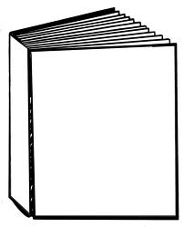](http://www.google.co.uk/url?sa=i&rct=j&q=&esrc=s&source=images&cd=&cad=rja&docid=1YhjvC5bjPYVmM&tbnid=wRuzrAxLXJYjaM:&ved=0CAUQjRw&url=http://www.biz-mag.net/templates.php&ei=tL_SUpC4BIfV0QX1toHYBA&psig=AFQjCNE7rsHCFZ0KsykEpITp0ya0xEMtAg&ust=1389629724141600)C:\Users\DOREEN\AppData\Local\Microsoft\Windows\Temporary Internet Files\Content.IE5\XC6AW3AW\dglxasset[1].aspx

**Book focus –**

**Man on the Moon Beegu**

[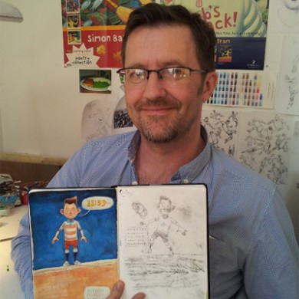](https://www.google.co.uk/url?sa=i&rct=j&q=&esrc=s&source=images&cd=&cad=rja&uact=8&ved=2ahUKEwjOyfaYmYXcAhVL8RQKHXFsANEQjRx6BAgBEAU&url=http%3A%2F%2Farenaillustration.com%2Fnews%2Fqa-simon-bartram-artist-profile%2F&psig=AOvVaw1S5OrnmRGGQcYXMZspt0f_&ust=1530785140734674)

Our author focus is

Simon Bartram

[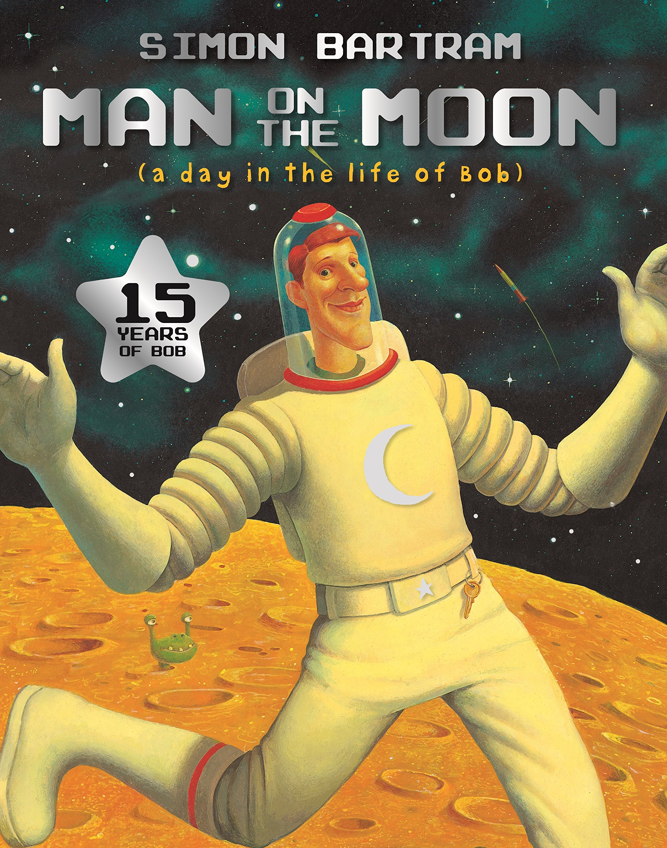](https://www.google.co.uk/url?sa=i&rct=j&q=&esrc=s&source=images&cd=&cad=rja&uact=8&ved=2ahUKEwjJh7-JmIXcAhVDuRQKHZevBrIQjRx6BAgBEAU&url=https%3A%2F%2Fwww.amazon.co.uk%2FMan-Moon-Bartram-Simon%2Fdp%2F1840114916&psig=AOvVaw3Mfbj5lrK7pWJdCVsuKcnH&ust=1530784766438158)

[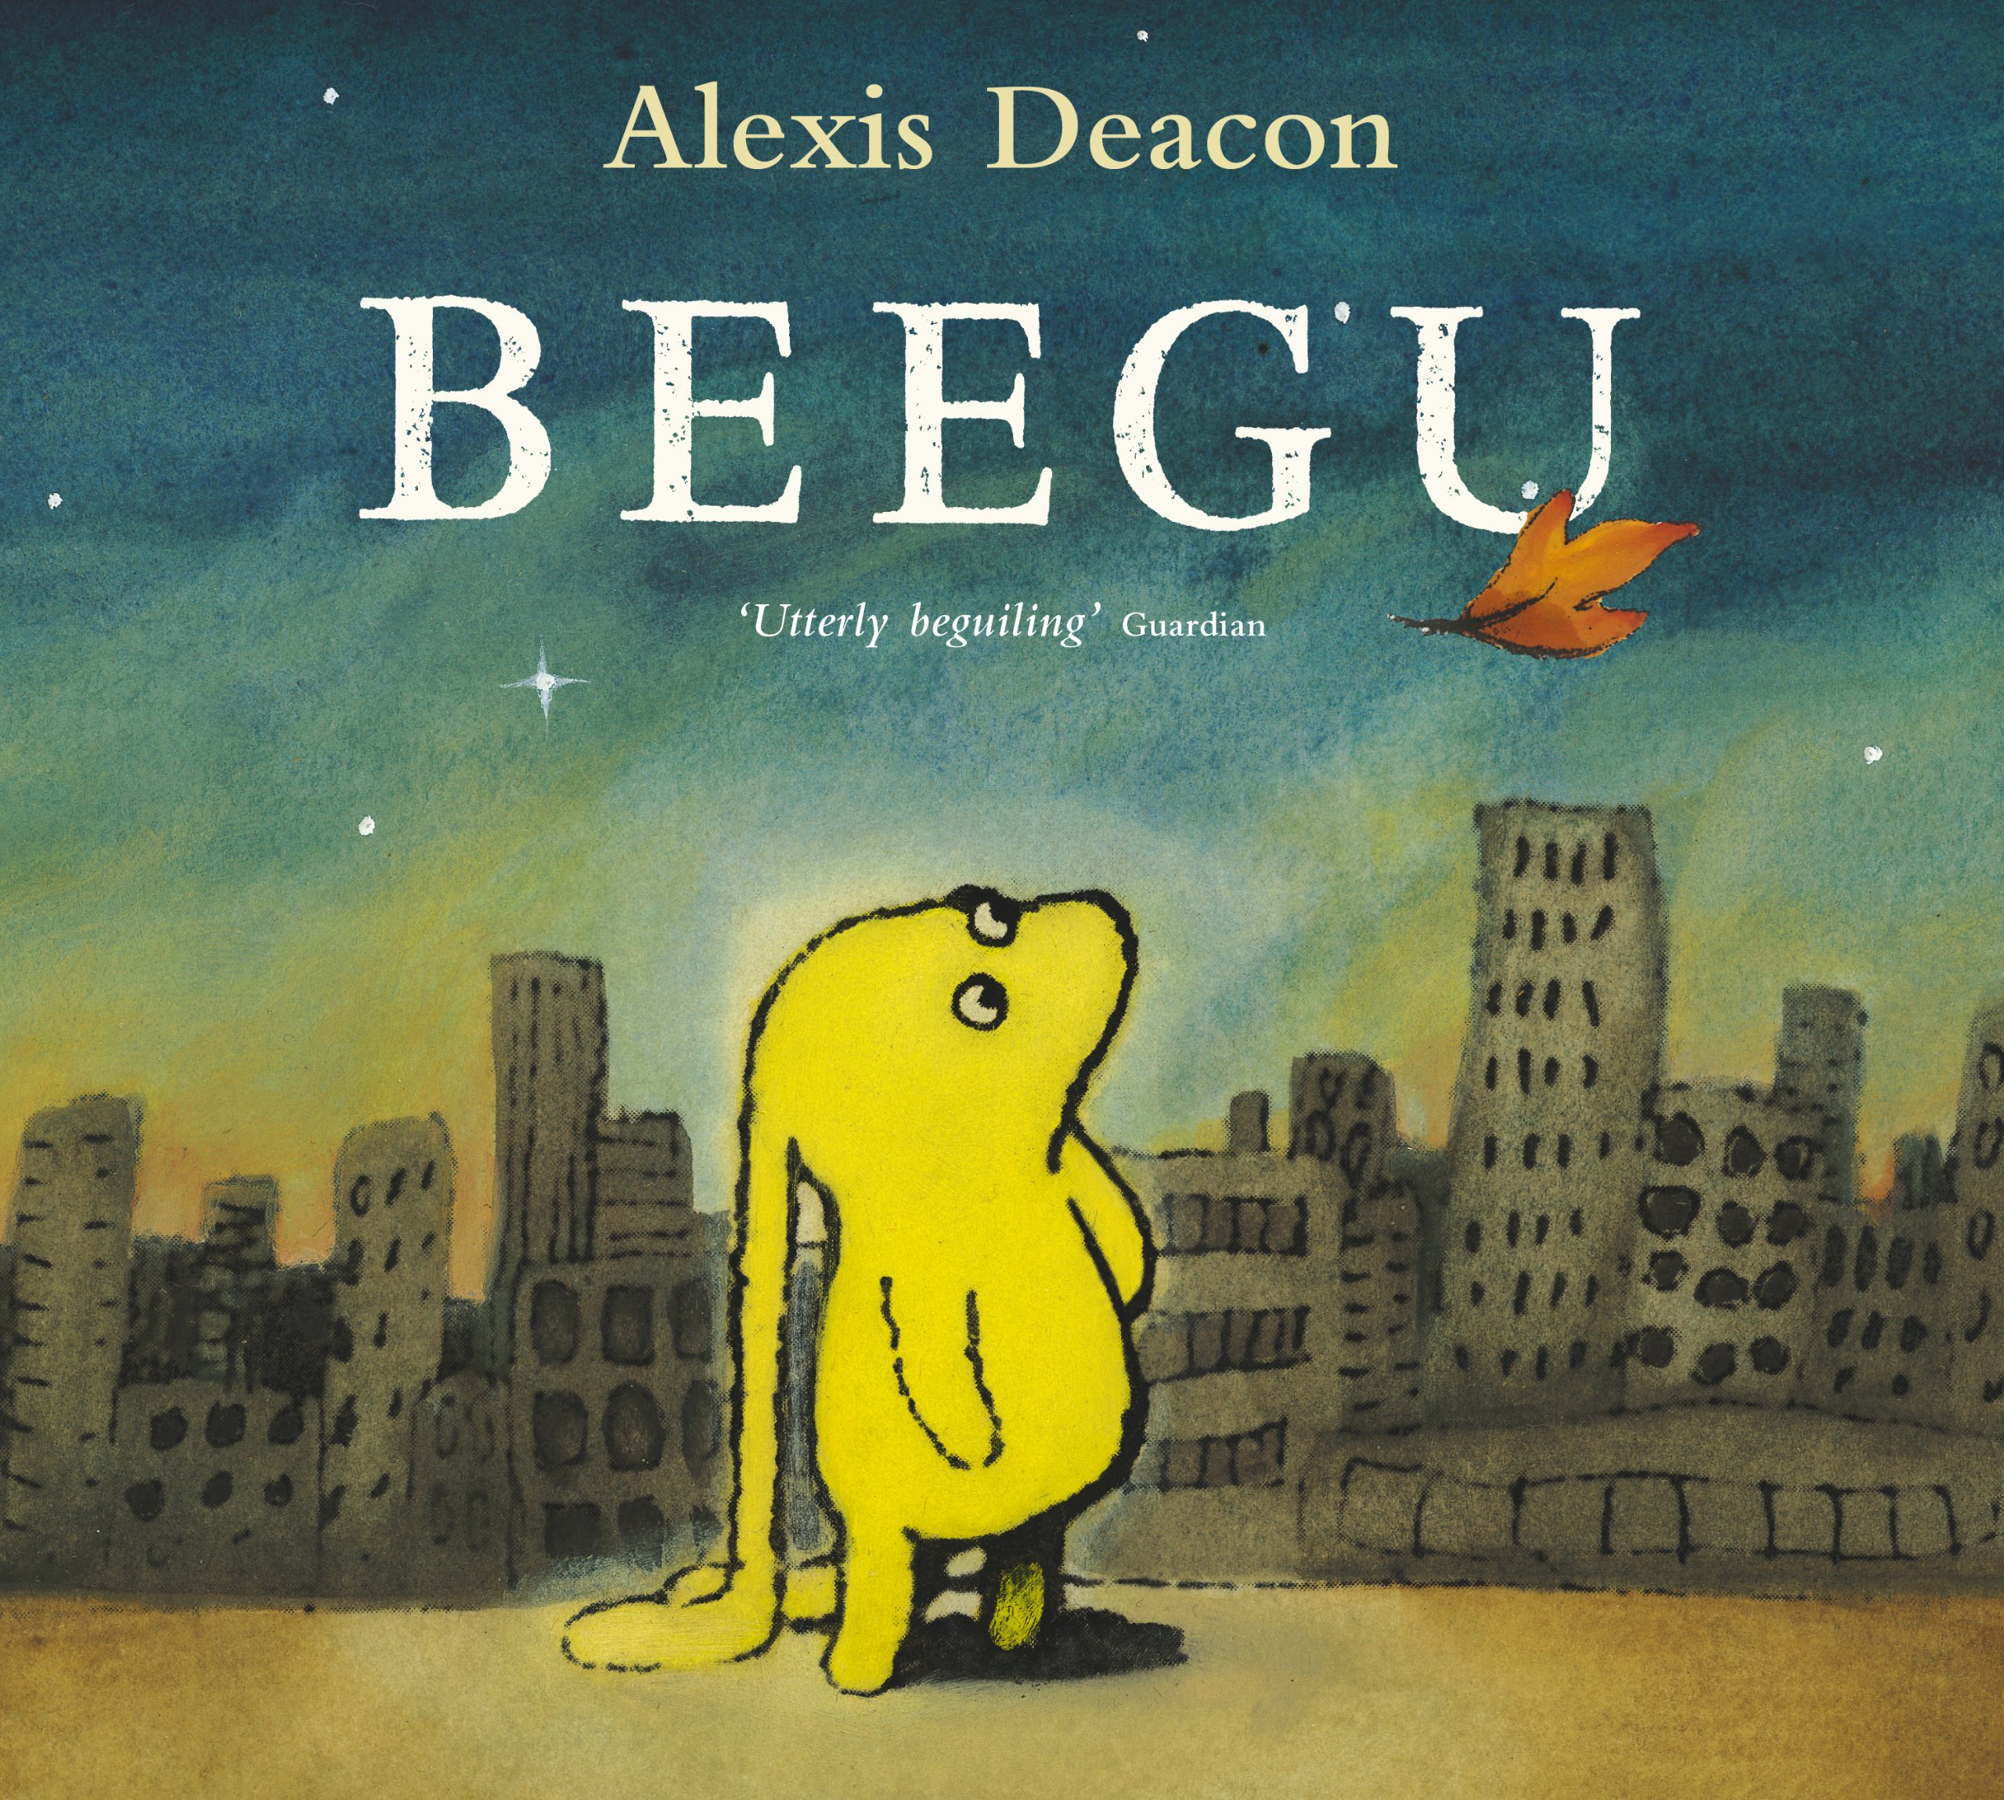](https://www.google.co.uk/url?sa=i&rct=j&q=&esrc=s&source=images&cd=&cad=rja&uact=8&ved=2ahUKEwiz77KoloXcAhXCbhQKHRArAvYQjRx6BAgBEAU&url=https%3A%2F%2Fwww.amazon.co.uk%2FBeegu-Alexis-Deacon%2Fdp%2F0099417448&psig=AOvVaw13tC-vq0R5BKyk8KTLZFhT&ust=1530784373967844)

**Heroes**

**Homework is given out on a Friday and handed in on a Wednesday. It is differentiated to suit the needs of each child.**

* **Spelling/Grammar Challenge**
* **Literacy/ Numeracy/Topic**
* **Reading**

**Possible trips and visits….**

* **Local walks – War memorial**
* **Planetarium**
* **Springfield Library**

**Homework**

**Our Mathematical Learning**

* **Place Value**
* **Addition and Subtraction**
* **Multiplication and division**
* **Money**
* **Counting in 2’s, 5’s and 10’s**
* **Space word problems**
* **Doubles and Halves**
* **Number bonds to 20**
* **Doubling, halving and quartering**
* **Using Tally charts/bar charts – ICT**

**Our learning**

* Dance – Tuesday afternoons
* Ball skills – Wednesday mornings
* War time heroes – Florence Nightingale
* Remembrance Day
* Space Heroes – Neil Armstrong and Tim Peake
* Heroes in the local community
* New beginnings/Target setting
* Core value – Teamwork
* Diaries, letters, postcards
* Art - Picasso
* DT – Space rockets
* Space /Materials
* Seasons
* UK flags and countries
* Singing – Class assembly songs
* Harvest art/songs/facts
* Diwali /Christmas/Hanukkah
* St Andrew’s Day
* Bonfire Night – Firework Safety
* RE – special things in nature
* Story mapping/Book making
* Creative story writing
* Drama/Puppet making
* DB Primary/Coding
* E-Safety
* Role play – Heroes dressing up shop

**and much more more!!!**