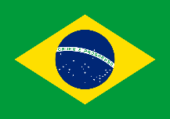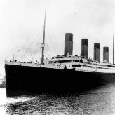

**Computing- Email and PowerPoint.**

Logon to DB primary with your username and password.

Go to the mail Icon (picture) and click on ‘Write Mail’.

Click on the address link and chose the person to send it to.

Then write the subject of your email (what it is about), type your email and press send!

This is the PowerPoint Icon:



**Science – Habitats and what plants need to grow.**

A habitat is a place that an animal lives. It provides the animal with food, water and shelter.

There are many different sorts of habitats around the world.

Animals eat plants and other animals within their habitats making a food chain.

A food chain always starts with a producer. A producer is a plant because it can produce/make its own food.

Plants need water, warmth, food and sunlight for healthy growth. Most plants produce flowers which turn to fruit.

**Wonderful Water- Knowledge Organiser**

**Year 2 – Spring Term**

**Geography – Comparing the UK with Brazil**

Brazil is a country in the

continent of South America.

The capital of Brazil is called Brasilia.

It has a population of around 194 million people.

The Amazon River flows through Brazil which is the second longest river the world.

Most of Brazil has a warm and tropical climate.

The Amazon Rainforest is in Brazil and it is home to millions of different plants/animals.

Brazil has a very long coastline which means it has many beaches. The beaches are sandy and beautiful! The sea is also very warm and full of tropical fish.

**History – The RMS Titanic**

The Titanic was a very large and very luxurious cruise ship that was built in 1912.

On the 10th April the Titanic set out on its maiden voyage (first journey) taking people from Southampton in England to New York in America.

The Titanic’s captain was called Edward John Smith and he had a crew of 900 people.

There were over 2200 people on board.

People travelled either in first class, second class or third class.

On the 14th April 1912 the Titanic hit an iceberg and tragically sunk.

There weren’t enough life boats on board the Titanic and many people sadly died when it sunk.