25.2.21 Can I generate adjectives?
Look closely at the picture.
Make a list of nouns (things Noi would see or hear when he looked out of his window). Then for each noun, think of some adjectives to describe it.
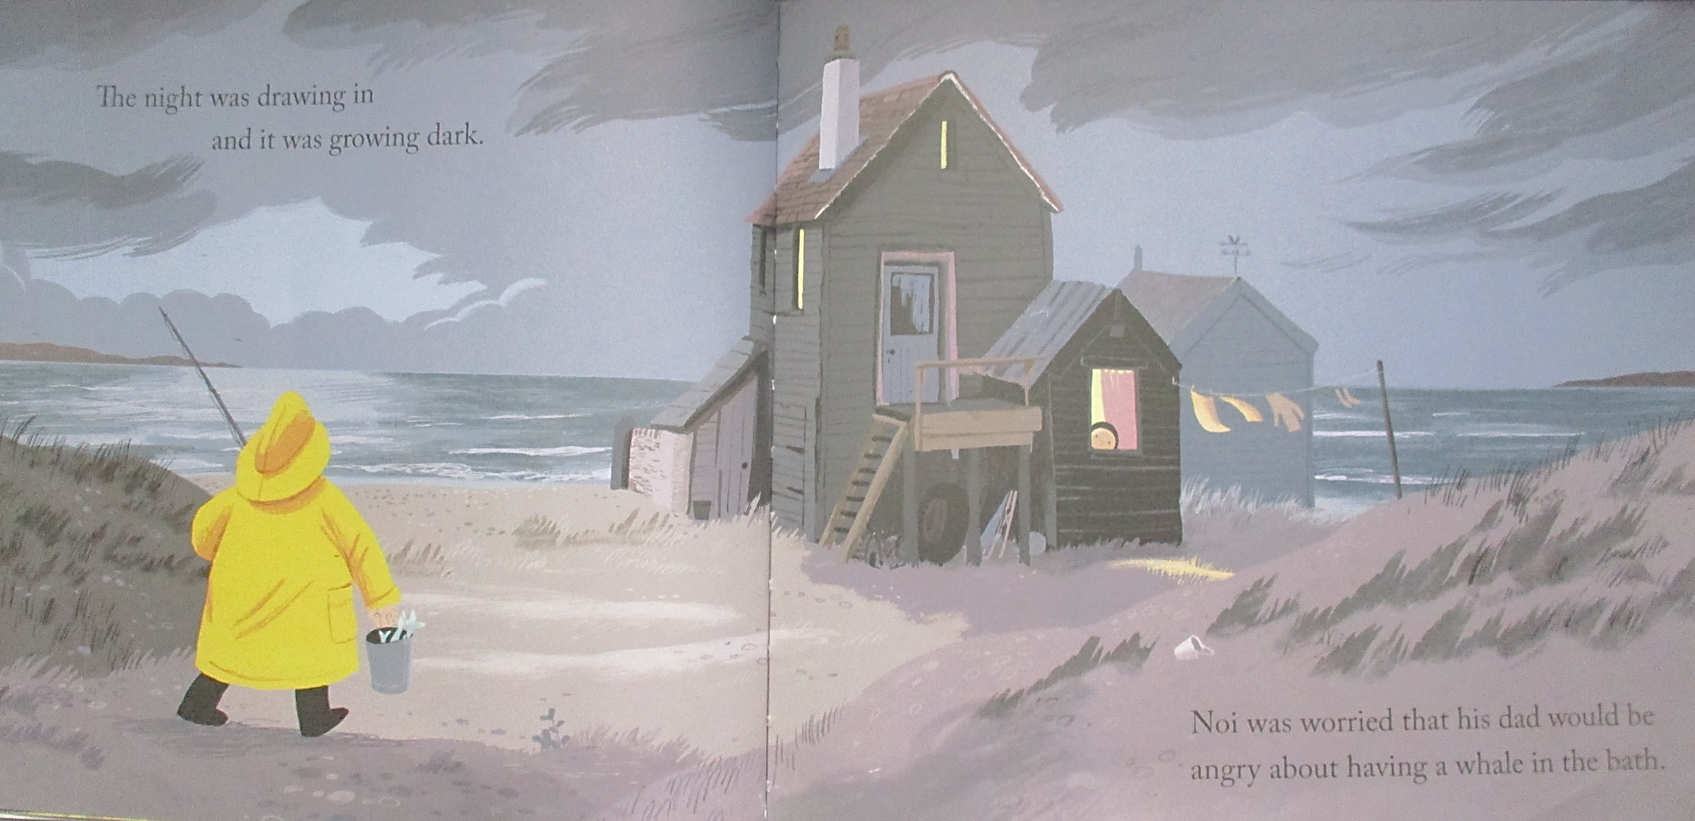
Nouns Adjectives

