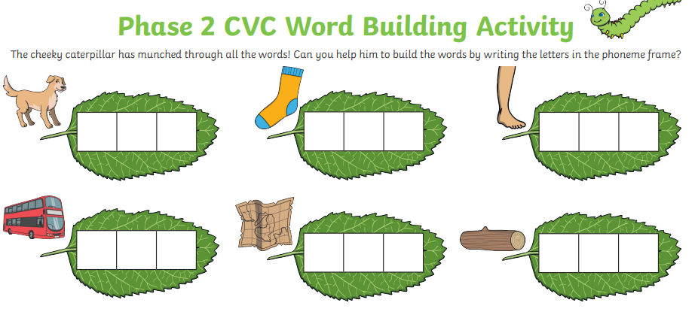
Wednesday 15th December Phonics Activity

Challenge
Write a sentence using as many of these words as you can.

