26.1.21 Can I identify the features in an information page.
All About France.
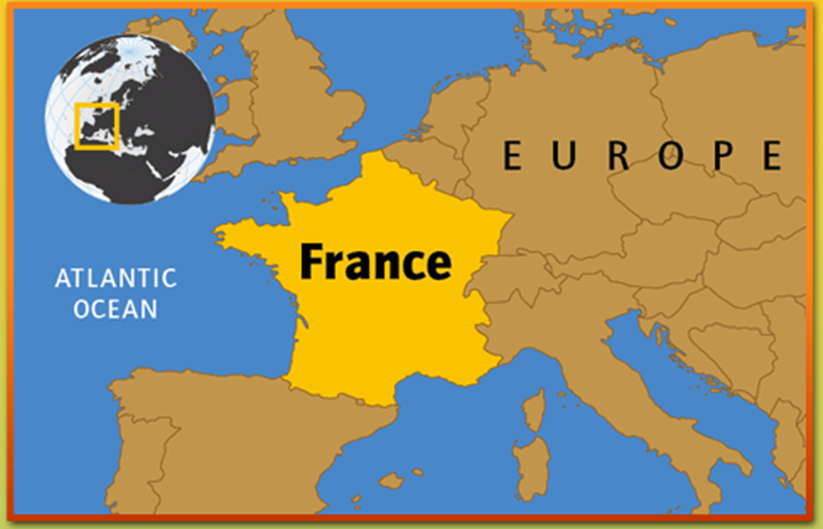
France is a big country in Europe. The capital city is Paris. People in France speak French.

This is France on a map.
There are lots of places to visit in France. One of the most famous places is the Eiffel Tower in Paris. Have you ever been to Paris?
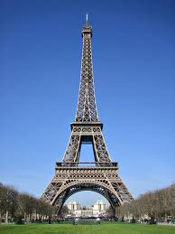
Circle the:
Title in red
Picture in blue
Caption in green
Question in yellow
The Eiffel Tower

