Basket Teddy Sending skills
Equipment: 4 teddys/bean bags/rolled up socks; a tea towel; and a bin/basket to throw into.
How to play:

Place a rolled up tea towel 2 meters away from the bin/basket- this is the throwing line. Stand behind the throwing line and gently underarm throw it aiming for the bin/basket. Stay still regardless of whether you have hit the target or not! Use both hands to throw or just your writing hand
Repeat with the remaining 3 teddys/bean bags/rolled up socks.

Teddy bears Starting line Basket or Bin
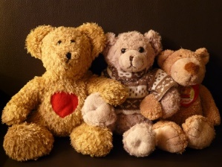
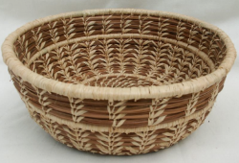

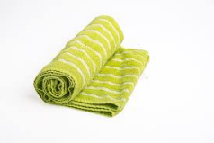

Make it easier – bring the target closer to the rolled up tea towel. Pick up any that miss and try again.
Make it harder- move the target further away from the starting line.

Skill Tip: When throwing, if you use your right hand, step forwards onto your left foot. If you use your left hand , step forwards on your right foot. It helps you to balance and become more accurate.

What is your best score today? Try again another day and see if you can get better over the week.

Challenges:
- Once you get 4/4 with your writing hand, then try with your non-writing hand to throw
- How many can you get in 20 seconds?
- Can you balance one teddy on your head while throwing?

STEP principle of coaching/teaching- helps to engage, challenge and motivate everyone by altering one or more of the principles
Space - make the target bigger or smaller . Change the level of the target, have it on a table or a chair.
Task – try standing on one leg as balancing while throwing is difficult!
Equipment – use a different size of teddy/bean bag/rolled up socks
People – Play against a friend/family member

Video No Video for this game

Dancing dice Your memory and imagination
Equipment: a dice
How to play:
Roll the dice to create your own unique dance! Each roll of the dice gives you a new dance move. Follow the instructions below and throw some shapes. Dance to music or your own rhythm, alone or with friends/family members. Use your imagination and maybe make up some moves of your own.

If you throw a...
1. Around the world – Balancing on one foot, spin around.
2. Leaping frog – Crouch down on the ground and jump up in the air, with your arms out wide.
3. Tippy tap – Stand with your hands on your hips, tap your foot in front of you, to the side and behind you. Repeat with the other foot.
4. Rollin’ – With your hands in fists, bend your arms out in front of you and roll one over the other, repeat four times and then roll them backwards.
5. Hip hop – Stand on one leg, with one arm straight above your head. Hop 3 times and punch the air each time. Repeat on the other leg.
6. Freestyle twist! – Go wild and try whatever moves feel fun. Try something different every time you throw a six.

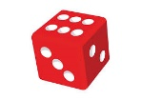

Skill Tip: keep the moves simple and low to the floor to start with, then progress onto jumping higher

Challenge:
- Can you remember all 6 moves?
- Can you throw the dice twice and link those 2 moves together?

STEP principle of coaching/teaching- helps to engage, challenge and motivate everyone by altering one or more of the principles

Space - make your arms and legs straighter when you spin around to use the space more
Task – Going higher up on your tip toes increases the difficulty!
Equipment – Add in some background music to get you in the groove and also to give your brain something else to think about!!
People – Get a family member to join in- can they copy you?

Video No Video for this game

Over and under Communication and co-ordination skills
Equipment: one large light ball
How to play:
A children’s party classic!!
Stand in a line with your family members one behind the other, all facing in the same direction
The person at the front lifts the ball over their head and passes it to the person behind them and then goes and joins the back of the line
The second person passes the ball between their legs (under the body) to the next person before moving to the back of the line
Then over the head, then under the body and so on

Skill Tip: Use both hands when passing the ball and communication will help!!

If over and under is difficult for the children to understand, then try a few minutes of everyone passing over and then a few minutes of passing under, before then alternating

Challenge:
- Can you reach forwards and help your family member in front of you?
- Can you stand at the side and tell your family members which move they should do?
- Can you pass the ball sideways around your waist instead of under and over?

STEP principle of coaching/teaching- helps to engage, challenge and motivate everyone by altering one or more of the principles
Space - try and stand fairly close to each other so you don’t need to stretch too far
Task – speed up the passing of the ball and your movement to the back of the line
Equipment – Try with a smaller ball or even a balloon?!
People – Get more family members to join in (if you have the space- or go outside)

Ball roll Sending & receiving skills
Equipment: one large light ball
How to play:
Two people (minimum) sit on the floor with their legs spread out and toes touching (see picture)
The youngest person starts with the ball and rolls it using both hands to the person sat opposite from them
They receive the ball and roll it either back (if playing with 2 people) or onto another person (if more than 2 are playing)
Once the ball is being passed nicely and under control, then take one step backwards so your toes no longer touch- can you all still keep control of the ball?

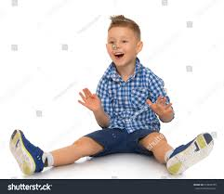

Skill Tip: Use both hands behind the ball to roll it to start with. Encourage both hands to point towards where you want the ball to go. When receiving the opposite should happen- hands are on the top cushioning the ball into the body

Challenge:
- How many rolls can you do in 20 seconds?
- Can you roll with just one hand instead of both?

STEP principle of coaching/teaching- helps to engage, challenge and motivate everyone by altering one or more of the principles
Space - try and keep your legs straight so you have a bigger area to roll the ball within
Task – speed up the passing of the ball between players
Equipment – Try with a smaller ball
People – Get more family members to join in (if you have the space- or go outside)

Spell your name Imagination
Equipment: a piece of A4 paper or a whiteboard and pen
How to play:
Think about the spelling of your name. An adult writes your name on a piece of paper or whiteboard in large font. Look at the shapes created by each letter- some are straight and some are curvy and some are a mixture of both.

Can you re-create these letters with your body standing up?
Can you re-create these letters with your body lying down on the floor?

Skill Tip: If you have a mirror the see how close you are to that letter. If you have a family member who can either take a picture of each letter or a video so you can see yourself.

Challenge:
- What about spelling your name all in capitals?
- Can you move into each letter shape using a different move/way of travelling?
- Can you add some background music to your performance?

STEP principle of coaching/teaching- helps to engage, challenge and motivate everyone by altering one or more of the principles

Space - try and keep your legs straight so you have a bigger area to roll the ball within
Task – speed up the passing of the ball between players
Equipment – Try with a smaller ball
People – Get more family members to join in (if you have the space- or go outside)

Bean bag balance Balancing skills
Equipment: bean bag or quoit or small teddy bear
How to play:
Place the bean bag on your head- does it slip off easily? Why does this happen?
Look straight ahead. Make it harder by looking side to side.
Balance the beanbag on their arm and explore moving their arm in space?
What other body parts can they balance the beanbag on? Share fun examples for the children to try such as top of the foot, elbow, back of hand, shoulder
Try walking forwards without the bean bag slipping off

Skill Tip: Balance on the whole of your foot including your toes and your heel.
Look forward at something still and keep your head up.
Hold your arms out wide to help you balance.
Challenge:
- Try walking quickly from one side of the room to the other with the beanbag on their head without dropping it?
- Try walking with the beanbag on a different body part without dropping it?
- Try walking sideways with the beanbag on their head, then on a different body part?
- Try walking backwards with the beanbag on their head, then on a different body part?
- Try balancing with the beanbag on their head with their eyes closed
- Try balancing while bending down to touch the floor whilst standing on one foot.

STEP principle of coaching/teaching- helps to engage, challenge and motivate everyone by altering one or more of the principles

Space - Use a larger space to move within
Task – smaller body parts to balance the bean bag on
Equipment – Try with a teddy bear or something that doesn’t mould to the heads shape
People – hold a conversation with someone whilst balancing or try and sing a song!

Full body rock, paper, scissors Timing, body control
Equipment: none
How to play:
A full body version of the traditional game played with your hands-
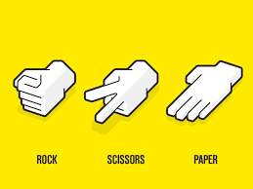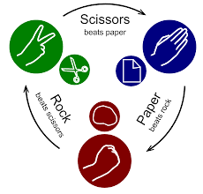

Once you have taught your child how to play Rock, Paper, Scissors with their hands and which one beats the other (see diagram above), give it a try with their full body!

Watch the 2 video clips for more info on the 3 stances (info below)
Play best of 3 but remember if you tie, you need to go again.
You can come up with a forfeit for the loosing person (such as 3 star jumps, jogging on the spot etc)

Skill Tip: count out loud “1,2,3” when you’re bouncing so they know straight after they need to get into their chosen position
Challenge:
STEP principle of coaching/teaching- helps to engage, challenge and motivate everyone by altering one or more of the principles

Space - try and keep your legs and arms straight when performing the paper and scissors action so that the movement is clear as to which one you are doing
Task – speed up the bouncing in between when counting “1,2,3”
Equipment – no equipment is used
People – Get more family members to join in so you can create a mini tournament by playing the first person to 3 wins.

Video https://www.youtube.com/watch?v=HX8cT29AVQM
https://www.youtube.com/watch?v=sZhfingx2eU from 1minute 30 onwards

Mini circuits Fitness
Equipment: none
How to play:
Pictures from Twinkl.co.uk
Look at the pictures below. Pick 9 of them that you would like to do (feel free to try them out first and then decide on your 9)
Try and do 3 of each of the 9 exercises, with a little rest in between each.
Challenge:
Can you do 5 of each?
Instead of 9 exercises, could you do all 12 from the top card?
On another day, can you complete all 12 exercises from the bottom card?

Jumping Challenge Jumping skills
Equipment: something to create a line e.g. skipping rope, wooden spoon, rolled up newspaper
How to play:
Use a skipping rope, wooden spoon, rolled up newspaper to create a flat line on the floor.
To start with step over the lines from left to right then back again
Then jump from one side to the other using ‘soft’ bended knees when you land.
Keep your feet glued together.
How many jumps can you do in 20 seconds?

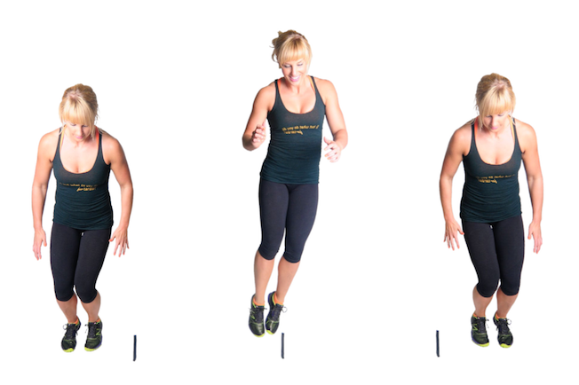
Skill Tip: Use your arms to help you gain momentum and bent knees and ankles to land softly

Challenge:
- Instead of a line use a raised wedge. Must be able to collapse easily. E.g. a teddy, a small cushion, or toilet roll tube standing vertically.

STEP principle of coaching/teaching- helps to engage, challenge and motivate everyone by altering one or more of the principles

Space - Try and stay fairly close to the line when you start and finish so you should be aiming to mainly jump up
Task – create a wedge or equivalent so you have to jump higher
Equipment – create a wedge or equivalent
People – Get more family members to join in- can you beat their score in 20 seconds?

Running Challenge Fitness
Equipment: Plastic coins or lots of pairs of rolled up socks and a bin or target to hit
How to play:
This can take place inside or out- if you are outside, then maybe use pebbles or stones- if you are inside then maybe some plastic coins or lots of pairs of rolled up socks.
Place a marker on the floor (such as a rolled up tea towel or cushion or sock) and then place a basket/bin/bucket around 5 big paces away. Have a pile of coins next to the marker.
To start, pick up a coin and run and put it in the bucket- don’t throw it in, drop it in. Run back and repeat.
How many coins can you put in the bin in 20 seconds?

5 big paces
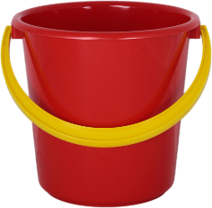

Skill Tip: Try and run normally and bend your knees rather than your back when you are picking up the coins/pebbles/socks
Challenge:
- Balance the coin on a part of your body. Do not use your hands!
- If you have a variety of coins- can you try and collect the higher value coins first?
- If you have a variety of coins, can you add up the number of each coin you managed to collect in 20 seconds?

STEP principle of coaching/teaching- helps to engage, challenge and motivate everyone by altering one or more of the principles

Space- Increase the distance from 5 big paces to 8 or 10 (if you have the space)
Task – Add in the maths challenges above, so a decision on which coin is to be selected is added in
Equipment – smaller coins/objects require finer motor skills with the fingers
People – Get more family members to join in- can you beat their score in 20 seconds?

Minefield Balance
Equipment: 8 objects such as rolled up socks, bobble hats, teddy bears, tea/hand towels
How to play:
Using your lounge/dining room/bedroom floor/outside space, place the objects (mines) you have gathered above all over the floor spreading them out as much as possible
Your task is to get from one side of the room to the other without touching the objects with your feet or any other body parts
Can you walk through?
Can you skip through?

Skill Tip: Hold your arms out to the side to help you to balance

Challenge:
- Can you walk more quickly?
- Can you move backwards?
- Can you close one eye and still complete the course?
- Can you balance a bean bag or small teddy bear on your head whilst moving?
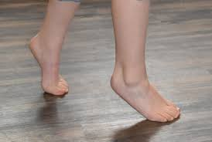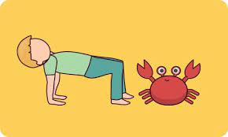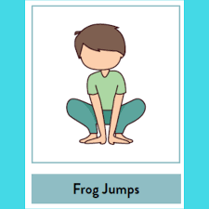
- Can you walk on your tip toes? Can you move sideways like a crab? Or jump like a frog?

STEP principle of coaching/teaching- helps to engage, challenge and motivate everyone by altering one or more of the principles

Space - Use your imagination when working out your route across the space- don’t always go the same way
Task – Use a different way of travelling every time- can you think of anymore?
Equipment – Try with a more objects on the floor (mines)
People – Get more family members to join in (if you have the space- or go outside?) can two or more of you be on the minefield at the same time and still not touch any of the mines?

