[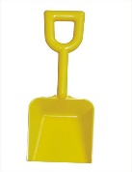](https://www.google.com/url?sa=i&url=http%3A%2F%2Fclipart-library.com%2Fshovel-pictures.html&psig=AOvVaw0zUxD-gPF-DtXbK2ebvbbg&ust=1594468924464000&source=images&cd=vfe&ved=0CAIQjRxqFwoTCPiqxrDSwuoCFQAAAAAdAAAAABAD)[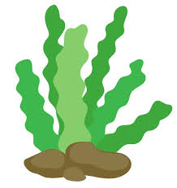](https://www.google.com/url?sa=i&url=http%3A%2F%2Fgclipart.com%2Fseaweed-clipart_23224%2F&psig=AOvVaw2f8jj_QVDe4PEIlsAxQzHT&ust=1594468843113000&source=images&cd=vfe&ved=0CAIQjRxqFwoTCNDX64nSwuoCFQAAAAAdAAAAABAD)[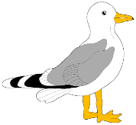](https://www.google.com/url?sa=i&url=http%3A%2F%2Fclipart-library.com%2Fseagull-cliparts.html&psig=AOvVaw2ZKh2iXJQs5Af9WnbbFWlX&ust=1594468753261000&source=images&cd=vfe&ved=0CAIQjRxqFwoTCOjw593RwuoCFQAAAAAdAAAAABAD)[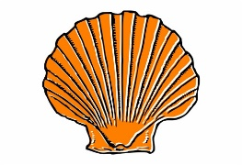](https://www.google.com/url?sa=i&url=http%3A%2F%2Fclipart-library.com%2Fclip-art%2F5-58389_small-clipart-sea-shell.htm&psig=AOvVaw26tb_AW9fx5TaXBG6GDFfJ&ust=1594468783176000&source=images&cd=vfe&ved=0CAIQjRxqFwoTCKCo2uzRwuoCFQAAAAAdAAAAABAD)[](https://www.google.com/url?sa=i&url=http%3A%2F%2Fclipart-library.com%2Fseagull-cliparts.html&psig=AOvVaw2ZKh2iXJQs5Af9WnbbFWlX&ust=1594468753261000&source=images&cd=vfe&ved=0CAIQjRxqFwoTCOjw593RwuoCFQAAAAAdAAAAABAD)[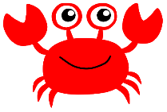](https://www.google.com/url?sa=i&url=http%3A%2F%2Fclipart-library.com%2Ffree%2Fcrab-clipart-png.html&psig=AOvVaw0oun7FL9B0zVga3nqZKq7s&ust=1594468694173000&source=images&cd=vfe&ved=0CAIQjRxqFwoTCOiLtsHRwuoCFQAAAAAdAAAAABAD)[](https://www.google.com/url?sa=i&url=https%3A%2F%2Fwww.pinclipart.com%2Fmaxpin%2FmJxRJm%2F&psig=AOvVaw3GNlFogTp6UBsYucqhPmO2&ust=1594468614740000&source=images&cd=vfe&ved=0CAIQjRxqFwoTCPibkJ3RwuoCFQAAAAAdAAAAABAD)[](https://www.google.com/url?sa=i&url=http%3A%2F%2Fwww.clker.com%2Fclipart-mint-ice-cream.html&psig=AOvVaw0Z_zkAZ--UAO4yTGreCxhy&ust=1594468534922000&source=images&cd=vfe&ved=0CAIQjRxqFwoTCJi4g_jQwuoCFQAAAAAdAAAAABAD)[](https://www.google.com/url?sa=i&url=http%3A%2F%2Fclipart-library.com%2Fbeach-ball-images.html&psig=AOvVaw1ZsbTXul2x-Z6nELocw8Os&ust=1594468478154000&source=images&cd=vfe&ved=0CAIQjRxqFwoTCKC76drQwuoCFQAAAAAdAAAAABAJ)[](https://www.google.com/url?sa=i&url=https%3A%2F%2Fwww.pinterest.com%2Fpin%2F107030928621758010%2F&psig=AOvVaw3Sdg9C5GfVzcIFeY-t1Hag&ust=1594468402523000&source=images&cd=vfe&ved=0CAIQjRxqFwoTCNiytrfQwuoCFQAAAAAdAAAAABAP)[](https://www.google.com/url?sa=i&url=https%3A%2F%2Fwww.pinterest.com%2Fpin%2F418905202809903527%2F&psig=AOvVaw01Unat6yIddFsXbULJhjxX&ust=1594468331757000&source=images&cd=vfe&ved=0CAIQjRxqFwoTCKjdk5bQwuoCFQAAAAAdAAAAABAD)**Can I complete a repeating pattern?**