[](http://www.google.co.uk/url?sa=i&rct=j&q=&esrc=s&source=images&cd=&cad=rja&docid=1YhjvC5bjPYVmM&tbnid=wRuzrAxLXJYjaM:&ved=0CAUQjRw&url=http://www.biz-mag.net/templates.php&ei=tL_SUpC4BIfV0QX1toHYBA&psig=AFQjCNE7rsHCFZ0KsykEpITp0ya0xEMtAg&ust=1389629724141600)[](https://www.google.co.uk/url?sa=i&rct=j&q=&esrc=s&source=images&cd=&cad=rja&uact=8&ved=2ahUKEwiwgfXjmoXcAhUEPhQKHc_hA58QjRx6BAgBEAU&url=https://www.zazzle.co.uk/gold_medal_1st_place_winner_button_classic_round_sticker-217252341849466606&psig=AOvVaw3dwAhIZpriwvTCIOiVGw5M&ust=1530785546676427)[](https://www.google.co.uk/imgres?imgurl=https://rlv.zcache.co.uk/gold_medal_1st_place_winner_button_classic_round_sticker-r1ee0e1164a824c95b5bb57ebb0318292_v9waf_8byvr_540.jpg&imgrefurl=https://www.zazzle.co.uk/gold_medal_1st_place_winner_button_classic_round_sticker-217252341849466606&docid=mjXU_GumytfuuM&tbnid=q5hVHSWzS96R6M:&vet=10ahUKEwjqwInXmoXcAhVlLcAKHR7YDCsQMwixAigbMBs..i&w=540&h=540&safe=strict&bih=724&biw=1518&q=medal%20&ved=0ahUKEwjqwInXmoXcAhVlLcAKHR7YDCsQMwixAigbMBs&iact=mrc&uact=8)C:\Users\DOREEN\AppData\Local\Microsoft\Windows\Temporary Internet Files\Content.IE5\XC6AW3AW\dglxasset[1].aspx

**Book focus –**

**Anna Hibiscus**

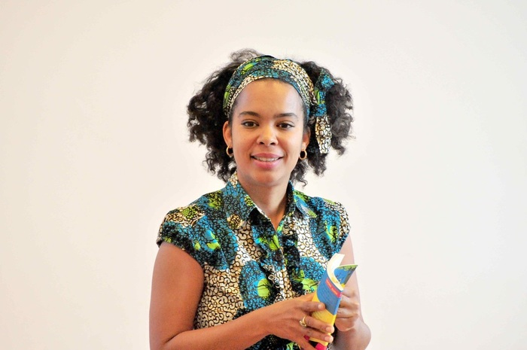

Homework is given out on a Friday and handed in on a Wednesday. It is differentiated to suit the needs of each child.

* **Spelling/Grammar Challenge**
* **Literacy/ Numeracy/Topic**
* **Reading**

**Our Mathematical Learning**

* **Multiplication and division**
* **Statistics – interpreting and creating tally charts, pictograms and bar charts**
* **Properties of 2D and 3D shape**
* **Fractions of amounts and shapes**
* **Measuring length**
* **Key instant recall facts: multiples of 10, doubles and halves**
* **Mental maths skills**
* **Solving problems written in different ways**
* **Revision of areas covered: place value, addition and subtraction, money**

**Possible trips and visits….**

* **Zoo/ wildlife park**
* **Springfield Library**

[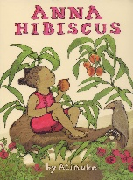](https://www.google.co.uk/url?sa=i&rct=j&q=&esrc=s&source=images&cd=&cad=rja&uact=8&ved=2ahUKEwjJh7-JmIXcAhVDuRQKHZevBrIQjRx6BAgBEAU&url=https://www.amazon.co.uk/Man-Moon-Bartram-Simon/dp/1840114916&psig=AOvVaw3Mfbj5lrK7pWJdCVsuKcnH&ust=1530784766438158)

Our author focus is

Atinuke

**African Safari**

**Homework**

**Our learning**

* New Year resolutions
* Core values – Honesty and curiosity
* PSHE – zoos/ captivity, caring for wildlife
* Art – African art
* Colour mixing
* Printing
* DT – using wheels and levers
* Safari vehicle
* Flags and countries of Africa
* Comparing places
* Climate
* Adaptation to hot places
* Food chains
* Properties of materials
* Drumming/ use of percussion
* RE – Passover and Easter
* Story writing
* Fact files
* Non-chronological reports
* Drama
* E-Safety
* 2Graph
* Powerpoint presentations
* Fencing – Thursday afternoons
* Ball skills – Wednesday mornings

**and much more more!!!**