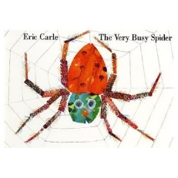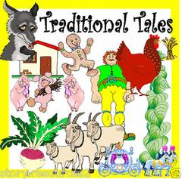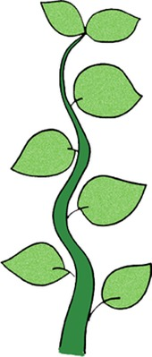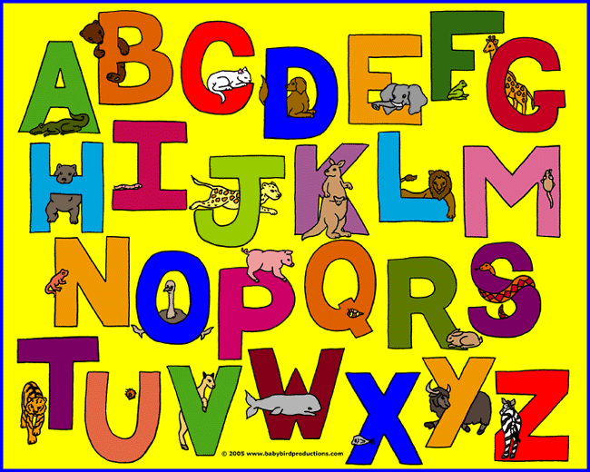

In understanding the world

* Looking at different habitats
* Using the iPads
* Looking at maps
* Learning about different cultures

Our homework is to:

* Read five times a week.
* Reading and writing tricky words and forming sentences.
* Looking at 3D shapes in the environment

**We will make…**

Flapjacks

Clay mice

Salt dough house number signs

**In Literacy**

Letters and sounds

Story writing

Story boards/maps

Character descriptions

Writing postcards

Salt dough recipes

Our author focus…

Eric Carle 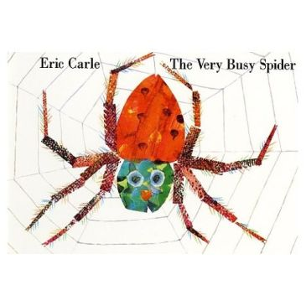

**In Maths**

Addition/subtraction

3D shapes and their properties

Capacity

Learning o’clock

One more and one less to 20 and above

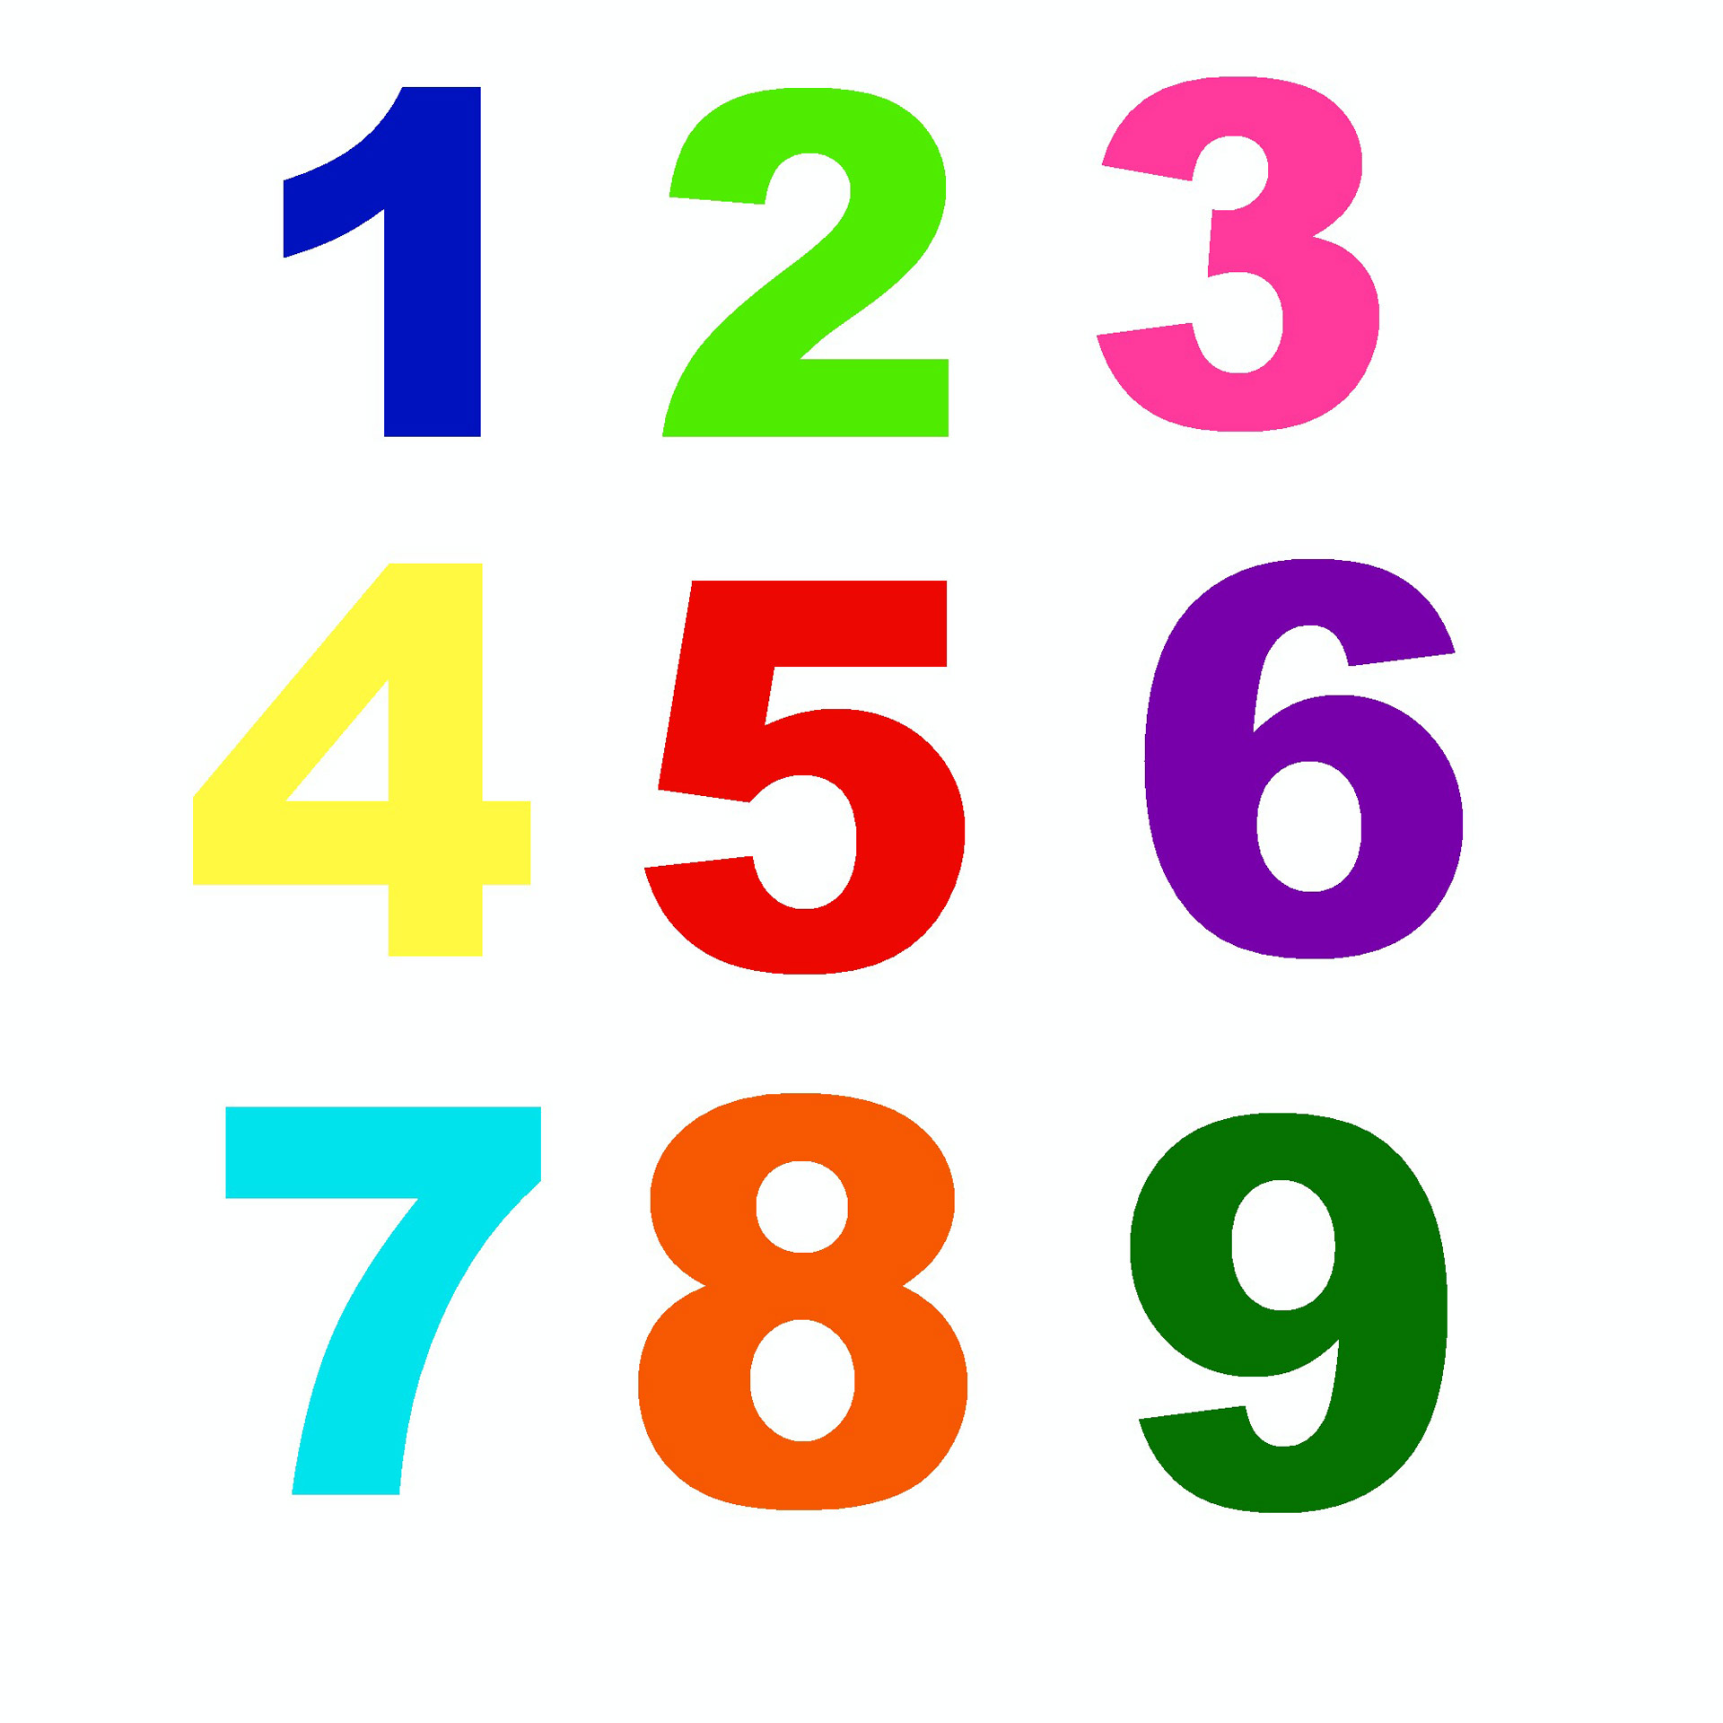

**Our topic this term is…**

A New House for Mouse!

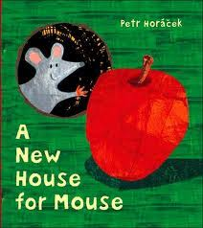

**Topaz and Ruby Classes theme this term is…**

**Watery World!**

**We will be learning all about…**

**In PE we will be doing…**

**Dance**

**Team games/ball skills**