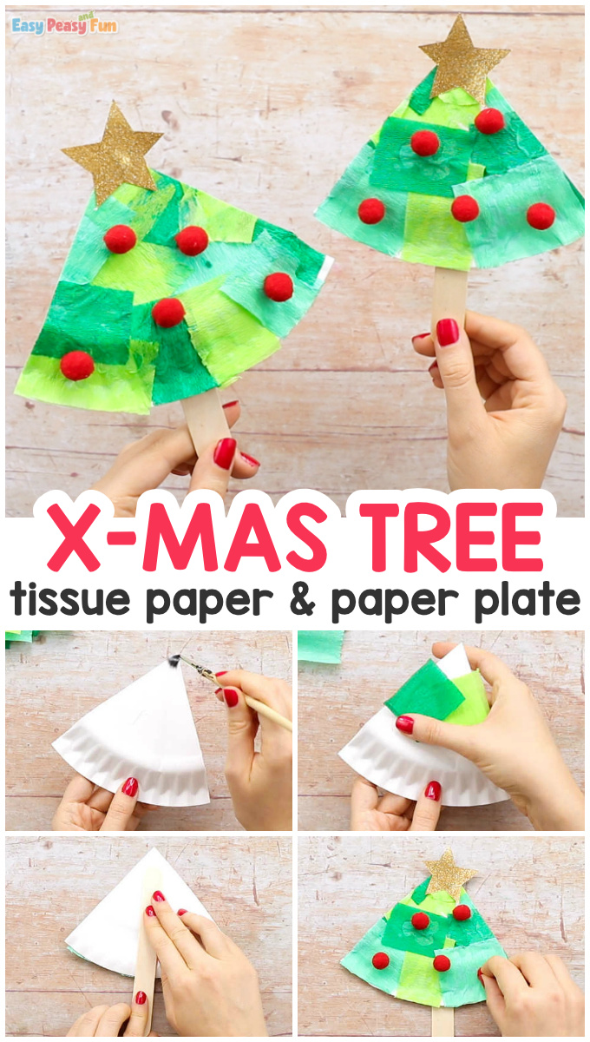

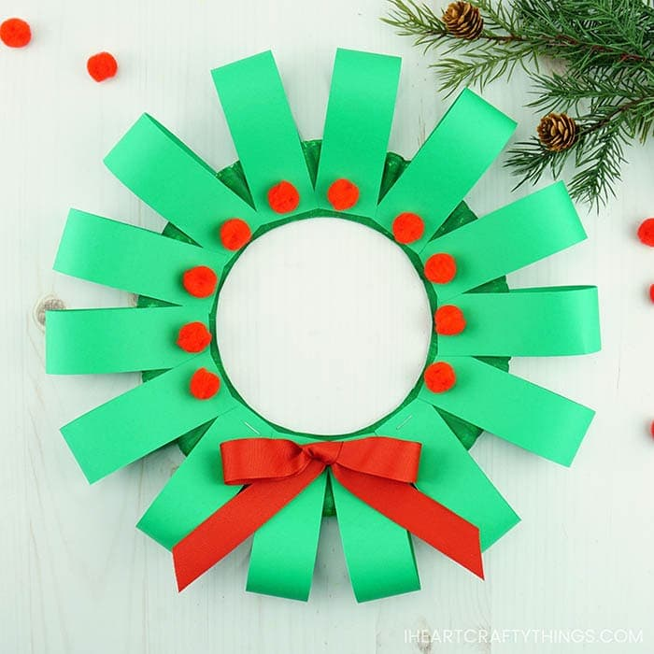

[](https://www.google.com/url?sa=i&url=https%3A%2F%2Fiheartcraftythings.com%2Fpaper-plate-christmas-wreath.html&psig=AOvVaw2I8nfPNIi0NtG55H5jhEbf&ust=1607592386473000&source=images&cd=vfe&ved=0CAIQjRxqFwoTCNCA6ZPLwO0CFQAAAAAdAAAAABAL)