Biscuit Recipe
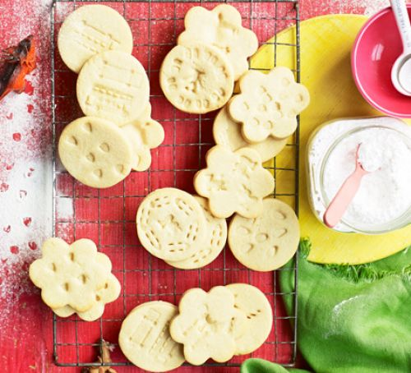

Ingredients
- 200g unsalted butter, softened
- 200g golden caster sugar
- 1 large egg
- ½ tsp vanilla extract
- 400g plain flour, plus extra for dusting

Method
- Heat oven to 200C/180C fan/gas 6 and line a baking sheet with baking parchment. Put the butter in a bowl and beat it with electric beaters until soft and creamy. Beat in the sugar, then the egg and vanilla, and finally the flour to make a dough. If the dough feels a bit sticky, add a little bit more flour and knead it in.
- Pull pieces off the dough and roll them out to about the thickness of two £1 coins on a floured surface. The easiest way to do this with small children is to roll the mixture out on a baking mat. Cut out shapes using a 9cm biscuit cutter, or a use the rim of a small glass and peel away the leftover dough around the edges. Press some clean toys gently into the biscuits, making sure you make enough of a mark without going all the way through. Re-roll off-cuts and repeat.
- Transfer the whole mat or the individual biscuits to the baking sheet and bake for 8-10 mins or until the edges are just brown. Leave to cool for 5 mins, then serve. Will keep for three days in a biscuit tin.
You could always have a go at decorating them and making them look like animals!

