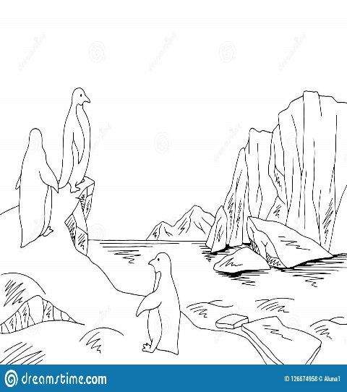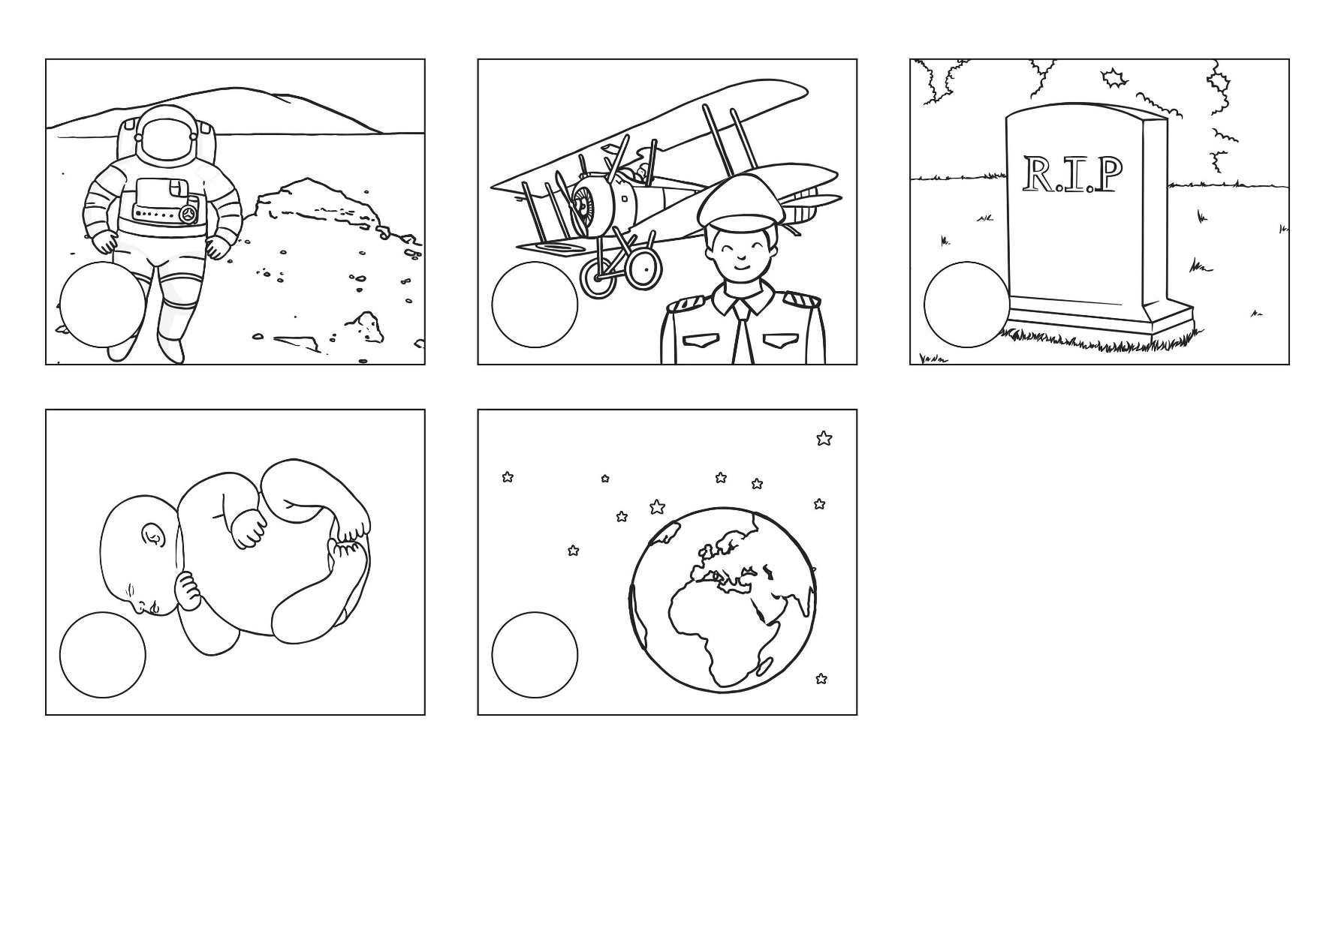

Robert Falcon Scott goes to Antarctica- 1912

Neil Armstrong died-2012

Robert Falcon Scott born-1868

Armstrong became a pilot- 1946

Armstrong’s first space mission-1966

Armstrong landed on the Moon-1969

Neil Armstrong born-1930