[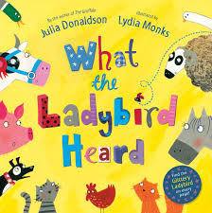](http://www.google.co.uk/imgres?imgurl=http://ecx.images-amazon.com/images/I/91qT3G36cTL._SL1500_.jpg&imgrefurl=http://www.amazon.co.uk/What-Ladybird-Heard-Julia-Donaldson/dp/0230706509&h=1500&w=1490&tbnid=6K6ZLizQ5am5-M:&zoom=1&q=what%20the%20ladybird%20heard&docid=QRYGZlNVfn9rWM&ei=Rc8RVPz3F4fnaOPOgPgO&tbm=isch&ved=0CCMQMygCMAI&iact=rc&uact=3&dur=498&page=1&start=0&ndsp=16)[](http://www.google.co.uk/imgres?imgurl=https://coderwall-assets-0.s3.amazonaws.com/uploads/picture/file/651/colorful_stripes_by_timpietrusky.png&imgrefurl=https://coderwall.com/p/4okplg&h=233&w=985&tbnid=nDuKToNSq5o_vM:&zoom=1&q=stripes&docid=FvHnypXVPddYOM&ei=3s8RVIS-Ic3-aO25gPgO&tbm=isch&ved=0CC4QMygNMA0&iact=rc&uact=3&dur=2395&page=1&start=0&ndsp=17)Name 

**Our Theme for Summer Term is……**

**Here We Are**

**Facts and Knowledge**

We will talk about our amazing world

We will be learning about…

Space

Our bodies

Ways to look after our planet

Different countries and their cultures

**Our focus author is…Oliver Jeffers**

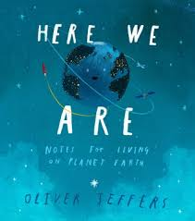

**Investigation Stations**

Maths- Can I halve and double amounts?

Understanding the World- Can I observe changes over time?

Can I investigate the best conditions for growing plants?

**We will create…**

The Solar System

Bird feeder

Under the stars box

**Our focus books are…**

**Here We Are**

**How to Catch a Star**

**Lost and Found**

**The Way Back Home**

Questions to ask

How can I keep my mind and body healthy?

How can we look after our wonderful world?

What makes me special/unique?

How does my body work?

**Wow Words**

**Planets, Earth, Solar System, space, land, sea, environment, pollution, habitats, atmosphere, unique, respect, patience, consideration, responsibility, tolerance.**