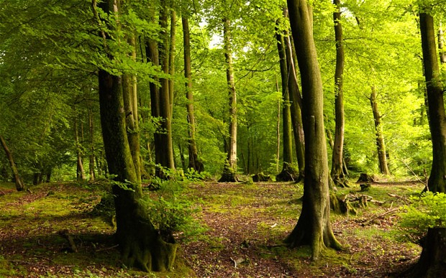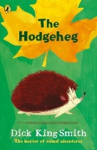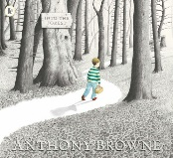

**In Sapphire and Emerald Class our topic will be…**

**Into the Woods**

**Our author focus is… Anthony Browne/Dick King Smith**

**We will make…**

Sewing animals

Woodland collages

Making porridge

Shoebox forests

**In Numeracy**

Number - Numicon

Counting in different steps

Ordering numbers

More/ less

Sequences

Tens and ones

Adding and taking away

2d woodland creatures

Our homework is to:

Learn spellings

One piece of maths or literacy

Read 5 times a week

**In Literacy**

Fairy tales – Hansel and Gretel/Three Little Pigs/Goldilocks/Snow White

Fact file writing

Labelling and classifying

Woodland creature riddles/poetry

The Hodgeheg– story writing/role play

Anthony Browne book reviews

Phonics

Fairy tale story writing

Book making

Instruction writing

**In understanding the world**

ICT – coding and DB Primary

Science -Woodland Habitats/plants/ testing materials/classifying animals

Forest school activities

**We hope to visit:**

**The Danbury Outdoor Centre