[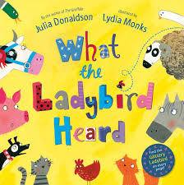](http://www.google.co.uk/imgres?imgurl=http://ecx.images-amazon.com/images/I/91qT3G36cTL._SL1500_.jpg&imgrefurl=http://www.amazon.co.uk/What-Ladybird-Heard-Julia-Donaldson/dp/0230706509&h=1500&w=1490&tbnid=6K6ZLizQ5am5-M:&zoom=1&q=what%20the%20ladybird%20heard&docid=QRYGZlNVfn9rWM&ei=Rc8RVPz3F4fnaOPOgPgO&tbm=isch&ved=0CCMQMygCMAI&iact=rc&uact=3&dur=498&page=1&start=0&ndsp=16)[](http://www.google.co.uk/imgres?imgurl=https://coderwall-assets-0.s3.amazonaws.com/uploads/picture/file/651/colorful_stripes_by_timpietrusky.png&imgrefurl=https://coderwall.com/p/4okplg&h=233&w=985&tbnid=nDuKToNSq5o_vM:&zoom=1&q=stripes&docid=FvHnypXVPddYOM&ei=3s8RVIS-Ic3-aO25gPgO&tbm=isch&ved=0CC4QMygNMA0&iact=rc&uact=3&dur=2395&page=1&start=0&ndsp=17)Name 

**Our Theme for Spring Term is……**

**Amazing Animals**

**Facts and Knowledge**

We will talk about different animals around the world using non-fiction books.

We will be learning about…

Arctic and Antarctic animals

Nocturnal animals

Lifecycles

Habitats

Domestic animals

**Our author focus is…**

**Nick Butterworth**

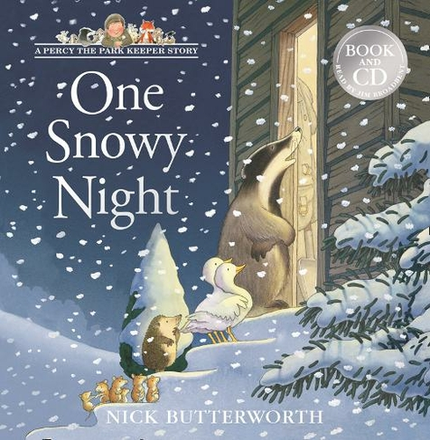

**Investigation Stations**

Maths- Can I estimate how many objects are in the container?

Understanding the World- Can I investigate which materials would be good to use for an animal home?

Can I investigate why animals have patterns? Why do some animals change colour?

**We will create…**

Animal homes

Animal prints

Animal pictures using natural materials

**Our focus books are…**

**Open Very Carefully**

**Meerkat Mail**

**Percy the Park Keeper stories**

**Giraffes Can’t Dance**

Questions to ask

Which animal would make a good pet?

What do pets need to keep them happy and healthy?

Which animals live in the wild?

**Wow Words**

Hibernation, nocturnal, habitat, wild, farm, Arctic and Antarctic animals, jungle, safari, zoo, under the sea creatures, life cycles, young, prey, mammals, reptiles, amphibians, birds, insects, fish, camouflage, carnivore, herbivore, omnivore, predator.